Reability Game Installation Guide

First , you must verify the port number that the game use to run in.
For example, angular web applications run on port 4200.

Open Valentina Studio, go to your local reability_dev DB and navigate to see the content of “game” table

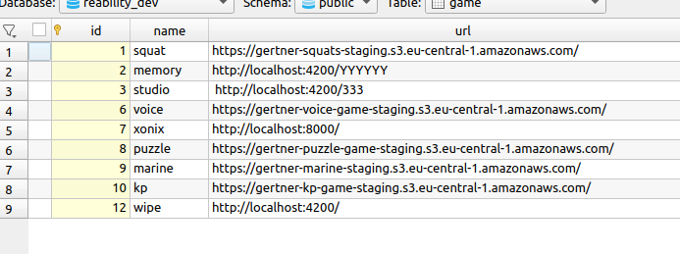
If you don’t see the name of the game you need to follow the bellow instructions in blue :
(and after that continue with the next instructions)

Open reability project in vs code

Open the .env file

Change the value of “SCRIPT_GAME_NAME” to the name of the game you need.

Change the value of “SCRIPT_BUCKET_NAME” to gertner-XXX-game-staging
(replace the XXX with the game name)

Save the file.

Open the vs code terminal (Ctrl-j) and run the following command:

npm run db:add:game
Refresh the view of the game table in Valentina Studio and verify that the new game is added.

Continue from here after verifying that a record of the game is in your local “game” table :

In the game table view - manualy change the value of the url column field of the specific game record to : http://localhost:XXXX/ - Replace the XXXX with the game port number
For example of angular game: http://localhost:4200/

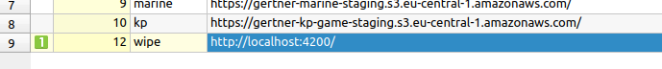

Open terminal in your main development folder (where all your projects are located).

Navigate in your browser to bitbucket and locate the game project.

Select the “Source” section and press the “Clone” button on the top right corner

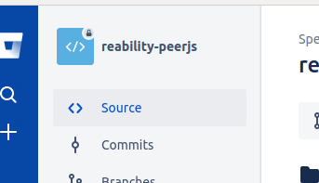

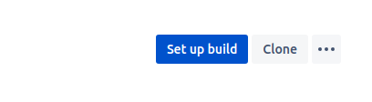

Make sure that in the dropdown in the top left “SSH” is selected and copy the “git clone….” command text and paste it in the terminal

Now you have the game project code in your development folder.

Open the game project in vs code and run the vscode terminal

Enter the following command:

npm run start

The game will start running locally.

To view it you need to use the reability application.

Run the reability application and you will see in the games menu , a game without an image,
(a broken narrow image missing icon)

Click on it and you will see the game you are running.

